The job of a signalman is to control rail traffic. The most important task is to ensure that two trains do not travel on the same line in opposite directions.
Today signals are controlled by computers. In the 1860s a signalman could only stop a train by standing on the line and waving a flag. It was difficult and dangerous work.

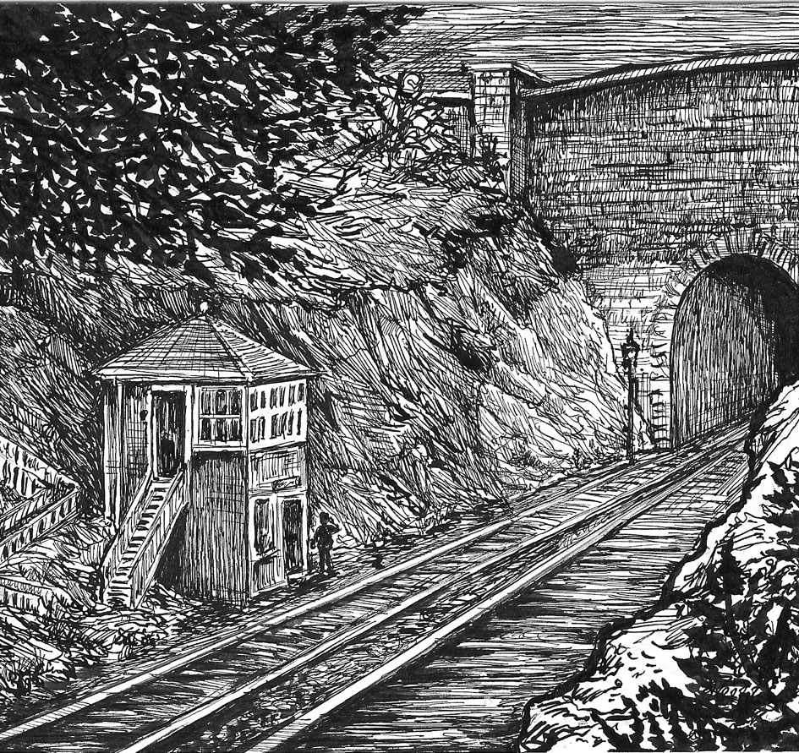
In the story
The signalman works on very quiet (‘lonely’) part of a railway line. His signal box is in a deep cutting, next to a tunnel.
- Inside the signal-box there is a machine with a little electric bell ... for sending telegraphs along the line.
- The signalman relies on telegraph messages. These provide information about trains travelling along the line.
- Each signalman along the line checks each train that passes his signal box.
- He then telegraphs ‘all clear’ to the other signalmen along the line.

Key Vocabulary
cutting - ground cut for a railway gloomy - dark, depressing, unlit
warn - advise of danger.
Telegraph - send message

troubled - worried/anxious/

signals - messages/warnings

Choose the correct word
- Trains travel under ground through tunnels/signals.
- Trains travel on tracks/signals
- The signalman raises a flag/track.
- A signalman/signal works in a tunnel/signal box.
- The signalman uses a signal/telegraph machine to send messages.

Writing
1. Look at the picture. Imagine you are the signalman standing next to the box. Describe your work. (15-25 words)
2. What do you think is going to happen to the signalman in the story? (20-50 words)

